EST

Practice Task 3
Year 12

2020

EXTERNALLY SET TASK GENERAL ENGLISH

___________________________________________________________________

The following feature article was published online by the ABC’s The Conversation, at https://www.abc.net.au/news/2020-02-20/criminal-penalties-corporate-wage-theft-wont-solve-problem/11985252?section=analysis.

Read the article and answer the question that follows it.

___________________________________________________________________

Criminal penalties for corporate wage theft are appealing, but won't fix the problem on their own
The Conversation
By Tess Hardy
Updated Thu at 3:21pmThu 20 Feb 2020, 3:21pm
Australian supermarket giant Coles and discount chain Target this week joined an ignominious list of large corporations caught up in "wage theft" scandals.
Coles confessed to underpaying salaried employees about $20 million over the past six years. Target admitted to underpaying staff about $9 million.
Other large companies guilty of underpaying employees include Bunnings, which underpaid its staff about $4 million in superannuation entitlements, and Woolworths, which underpaid employees up to $300 million over ten years.
These cases — along with a string of others involving small and medium enterprises — reinforce the need for reform.


Photo: Coles confessed to underpaying salaried employees about $20
Million over the past six years (ABC News: Tom Joyner).

Australian Attorney-General Christian Porter has said he will introduce legislation within weeks to criminalise the worst cases of worker exploitation and underpayment.
Heavier sanctions may be appropriate. But harsher civil or criminal penalties will not, on their own, lead to greater compliance.

Beyond penalties and punishment
Not surprisingly, Rob Scott, the chief executive of Wesfarmers (the parent company of both Target and Bunnings), is among those opposed to penalising companies for "inadvertent administrative errors".
"I'm not sure more punitive penalties are necessarily going to change behaviour at all," he said this week.

Photo: Other large companies guilty of underpaying employees including Bunnings, which underpaid its staff about $4 million in superannuation entitlements (AAP: Dan Himbrechts).


MONTHS AFTER APOLOGIES, WORKERS

STILL WAITING FOR WAGES
"There have been some significant issues across payroll systems in the market, which in part reflects the incredible complexity of the systems that we're dealing with."
Even if these underpayments were not deliberate, companies were — in the words of Fair Work Ombudsman Sandra Parker — "lax and lazy" about complying with their obligations.
As a growing list of companies admit to underpayments, it can be months or years before workers receive any money owed.

As a growing list of companies admit to underpayments, it can be months or years before workers receive any money owed.

It is hard to believe a corporation like Wesfarmers — one of Australia's ten biggest listed companies — does not have the resources to pay people correctly.
Nonetheless, Scott does raise a valid point. Changing the compliance culture in Australia will not be straightforward.
There is much research that suggests promoting, achieving and sustaining compliance with the law is about much more than just penalties, punishment and deterrence.
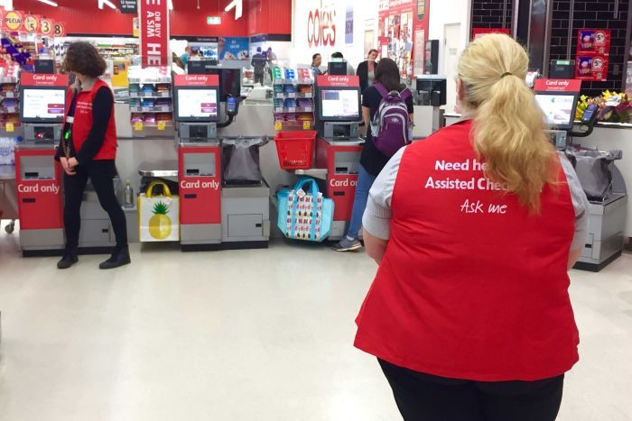
There is also limited evidence to support the idea that criminalising wage theft will alone act as a regulatory panacea.
This is especially the case where underpayment is primarily committed by corporations rather than individuals.

Risk of detection
My colleague John Howe and I have researched employer non-compliance with the Fair Work Act in the hairdressing and restaurant industries.
Our findings confirm conclusions drawn in previous studies relating to environmental violations, tax evasion and cartel conduct: it is the perceived risk of detection, not the severity of the sanction, that is most likely to enhance deterrence and encourage compliance.

oVERWORKED? UNDERPAID?
If the perception of being caught is critical, then what counts are the resources available to the Fair Work Ombudsman to strategically intervene and to be seen to be doing so — that is, by widely publicising enforcement outcomes.
On these points the current system has at least two vulnerabilities. These will remain even if criminal penalties are introduced and civil penalties increased.
First, various Federal Government commitments to boost funding for the Fair Work Ombudsman have not resulted in any discernible increase in the number of Fair Work inspectors or other staff.
It is no coincidence that trade unions — the organisations that have historically supplemented government detection efforts — are struggling to keep up with demand in the sectors most prone to wage theft, such as horticulture and hospitality.
While Porter is promising the "most vigorous, robust and complete set of laws around wage underpayment that Australia's ever seen", there's no sign the Government will do anything that might enhance the role of the union in this space.
Contraventions are generally detected by the regulator through proactive inspections and individual complaints. But most complaints are settled confidentially.
This may mean quicker redress for workers, but it has limited deterrent effect.

Effective reforms
The prospect of criminalising wage theft grabs headlines. But in making this change it is essential policy makers do not lose sight of the total reform agenda needed to make a real difference.
The Fair Work Ombudsman needs sufficient resourcing and enhanced enforcement tools and detection mechanisms. Dispute-resolution and court processes for workers seeking to recover pay need to be streamlined.
Finally, all of this should be publicised, so employers know transgressions of workplace law, inadvertent or not, have consequences.
Correction: this article's conclusion has been amended to remove imputations introduced during The Conversation's editing process. All activities of the Fair Work Ombudsman, not just possible prosecutions and penalties, need to be publicised for deterrence purposes.
Tess Hardy is a senior lecturer in law at the University of Melbourne. This article originally appeared on The Conversation.
First posted Thu at 1:23pmThu 20 Feb 2020, 1:23pm

Photo: Coles and discount chain Target this week joined an ignominious list of large corporations caught up in "wage theft" scandals. (ABC News: Raveen Hunjan)
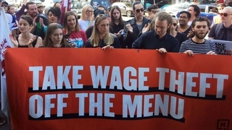
Here's your guide to getting the money your boss owes you.

Photo: There is also limited evidence to support the idea that criminalising wage theft will alone act as a regulatory panacea. (Giulio Saggin, file photo: ABC News)
EXTERNALLY SET TASK GENERAL ENGLISH
BIAS - definition
Would you trust information unsupported by facts or logical reasoning? A biased author may not pay attention to all the facts or develop a logical argument to support his or her opinions.
Bias is when a statement reflects a partiality, preference, or prejudice for or against a person, object, or idea. In short, it is a one-sided view of a topic. Much of what you read and hear expresses a bias. Bias is when a writer or speaker uses a selection of facts, choice of words, and the quality and tone of description, to convey a particular feeling or attitude. Its purpose is to convey a certain attitude or point of view toward the subject. As you read or listen to biased materials, keep the following questions in mind:
- What facts has the author omitted?
- What additional information is necessary?
- What words create positive or negative impressions?
- What impression would I have if different words had been used?
Biased information tries to change your mind or how you think. Being aware of bias and knowing how to identify, analyse, and assimilate biased information properly is a skill to be treasured. It puts you in charge of how you think.

Question 1 (25 marks)
Explain how the author creates bias (a one-sided argument) in the article above using facts, opinions, word choice and tone. Use paragraphs to organise your response.
_____________________________________________________________________________________
_____________________________________________________________________________________
_____________________________________________________________________________________
_____________________________________________________________________________________
_____________________________________________________________________________________
_____________________________________________________________________________________
_____________________________________________________________________________________
_____________________________________________________________________________________
_____________________________________________________________________________________
_____________________________________________________________________________________
_____________________________________________________________________________________
_____________________________________________________________________________________
_____________________________________________________________________________________
_____________________________________________________________________________________
_____________________________________________________________________________________
_____________________________________________________________________________________
See next page
_____________________________________________________________________________________
_____________________________________________________________________________________
_____________________________________________________________________________________
_____________________________________________________________________________________
_____________________________________________________________________________________
_____________________________________________________________________________________
_____________________________________________________________________________________
_____________________________________________________________________________________
_____________________________________________________________________________________
_____________________________________________________________________________________
_____________________________________________________________________________________
_____________________________________________________________________________________
_____________________________________________________________________________________
_____________________________________________________________________________________
_____________________________________________________________________________________
_____________________________________________________________________________________
_____________________________________________________________________________________
_____________________________________________________________________________________
_____________________________________________________________________________________
_____________________________________________________________________________________
_____________________________________________________________________________________
_____________________________________________________________________________________
_____________________________________________________________________________________
_____________________________________________________________________________________
_____________________________________________________________________________________
_____________________________________________________________________________________
_____________________________________________________________________________________
_____________________________________________________________________________________
_____________________________________________________________________________________
_____________________________________________________________________________________
_____________________________________________________________________________________
_____________________________________________________________________________________
_____________________________________________________________________________________
_____________________________________________________________________________________
See next page
_____________________________________________________________________________________
_____________________________________________________________________________________
_____________________________________________________________________________________
_____________________________________________________________________________________
_____________________________________________________________________________________
_____________________________________________________________________________________
_____________________________________________________________________________________
_____________________________________________________________________________________
_____________________________________________________________________________________
_____________________________________________________________________________________
_____________________________________________________________________________________
_____________________________________________________________________________________
_____________________________________________________________________________________
_____________________________________________________________________________________
_____________________________________________________________________________________
_____________________________________________________________________________________
_____________________________________________________________________________________
_____________________________________________________________________________________
_____________________________________________________________________________________
_____________________________________________________________________________________
_____________________________________________________________________________________
_____________________________________________________________________________________
_____________________________________________________________________________________
_____________________________________________________________________________________
_____________________________________________________________________________________
_____________________________________________________________________________________
_____________________________________________________________________________________
_____________________________________________________________________________________
_____________________________________________________________________________________
_____________________________________________________________________________________
_____________________________________________________________________________________
_____________________________________________________________________________________
_____________________________________________________________________________________
_____________________________________________________________________________________
See next page
_____________________________________________________________________________________
_____________________________________________________________________________________
_____________________________________________________________________________________
_____________________________________________________________________________________
_____________________________________________________________________________________
_____________________________________________________________________________________
_____________________________________________________________________________________
_____________________________________________________________________________________
_____________________________________________________________________________________
_____________________________________________________________________________________
_____________________________________________________________________________________
_____________________________________________________________________________________
_____________________________________________________________________________________
_____________________________________________________________________________________
_____________________________________________________________________________________
_____________________________________________________________________________________
_____________________________________________________________________________________
_____________________________________________________________________________________
_____________________________________________________________________________________
_____________________________________________________________________________________
_____________________________________________________________________________________
_____________________________________________________________________________________
_____________________________________________________________________________________
_____________________________________________________________________________________
_____________________________________________________________________________________
_____________________________________________________________________________________
_____________________________________________________________________________________
_____________________________________________________________________________________
_____________________________________________________________________________________
_____________________________________________________________________________________
_____________________________________________________________________________________
_____________________________________________________________________________________
_____________________________________________________________________________________
_____________________________________________________________________________________
End of the EST

